Wabash Tailgate!

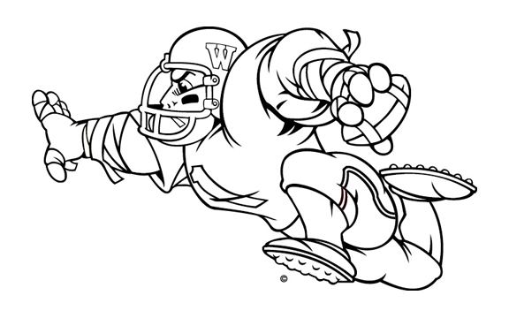
You are invited!
Join other Wabash College fans for a pre-game tailgate ‘Bash!

Wabash College
vs.

DENISON
Date: Saturday, November 4, 2006
Game time: 1:00 PM (local)
Tailgate: starts at 11:00 AM
Location: In the large parking lot (marked with a “P” on the map) directly between the Physical Education Center and the tennis courts. Campus map at http://www.denison.edu/campus/map.php)

No host and no cost: Just bring something to eat and drink and join other Wabash fans as we get ready to cheer the Little Giants on to victory.

Free raffle: As this is our last away-game tailgate, until the playoffs, we will have a free raffle for all attendees. Win something from the Wabash bookstore. This is our way of saying “THANKS!”
for being such great and loyal fans.

For any questions, contact Heather at bazzanih@wabash.edu or call 765-361-6360.

NOTE: This will be Wabash’s 1,000th football game!
